|  |
| --- |
| RD-Media Copyright 2013 |
| RD-Ticketmaster Documentation |
| For TM Version 3.0 and/or higher (Screenshots are taken from version 3.0.3) |



|  |
| --- |
| Dam, Robert  11-3-2013 |

Table of Contents

1: Control Panel 3

2: Category Overview. 4

2.1: Add/Edit categories in Ticketmaster 5

3.0: Ticket Overview. 6

3.0.1: Ordering your Tickets: 6

3.0.2:Counting Tickets: 6

3.0.3: Synchronizing and Cleaning up Ticket counters: 7

3.0.4: The Synchro Button: 7

3.0.5: The cleanup button: 7

3.0.6: Parent & Child Tickets 8

3.1: Add & Edit tickets 8

3.1.1: Choosing a different design for every ticket you enter. 9

3.1.2: Main Ticket information: 9

3.1.3: Setting Time and Date for your events: 10

3.1.4: Variable Ticket Positions: 11

3.1.5: Overriding the PDF creator. 12

3.1.6: Ticket Totals & The Ticket Counter. 12

3.2: Ticket information and the PDF File. 13

4: Sold tickets in Ticketmaster. 13

4.0.1: Resend Payment: 14

4.1: Showing the order details. 15

4.1.0: Order Details: 15

4.1.1: Remarks on order: 16

4.1.2: Ticketmaster Pro & Seatnumbers: 16

5.0: Ticketmaster Message Center. 17

5.1: Add message to Ticketmaster Message Center. 18

6: Venue Manager 19

6.1: Add/Edit Venues 20

6.1.0 Google Maps 20

7: Export Manager 21

7: You Clients/Visitors 22

7.1: Client Details 23

7.1.0: IP Address: 23

7.1.1: How to track happy clickers in your database? 23

8.0 Countries in Ticketmaster 24

8.1: Edit a country in Ticketmaster. 24

9.0 Coupon Management. 25

9.1 Adding coupons to your system: 26

10.0 Ticketmaster Configuration 27

10.1: Template settings 27

10.2: Payment options. 27

10.3: Main Component Settings: 28

10.4 Email Settings. 29

10.5 Event Page Settings 30

10.6: Checkout Settings 30

10.7: PDF Settings 31

1: Control Panel  
After installing Ticketmaster your Ticketmaster, you can see it in the components menu manager.  
Click the menu item in the administrator, and you will be redirected in the Control panel.  
  
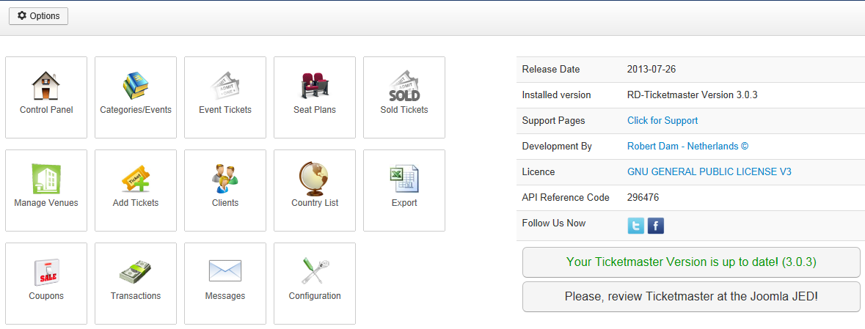

On the left of the page you will see the “Quick” buttons to go to the different sections of your Ticketmaster installation.  
At the right you will see the installed version, release date and support links. And last but not least, you can follow us on Twitter/Facebook. Very appreciated is a review at the Joomla JED, you only have to click the link.

The Green text indicates if you are running the latest version, if not you can click the link to go directly to our website for a download of the latest version.   
  
In the CPanel you won’t see a menu, but in every other page you will have a menu to navigate to another page quickly. Below you can see a screenshot of this menu: (blue arrow)   
  
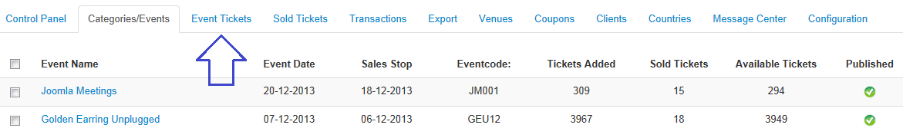

2: Category Overview.  
By clicking the categories button in the Control Panel of your Ticketmaster installation, you will see the categories:  
  
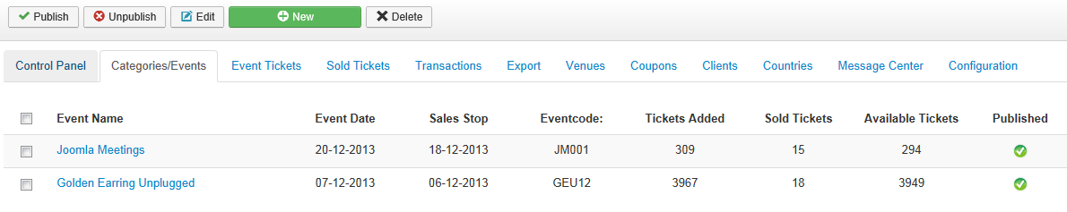

This page is an overview of entered events/ categories. In some older versions we’re calling a category an event also) Before you can start you need to add some events/categories to the system.   
  
On top you have the standard Joomla buttons:

* Publish *(Publishing an event or more than one)*
* Unpublish *(Unpublishing an event or more than one)*
* Edit *(Edit an existing event)*
* New *(Add a new event)*
* Delete *(Delete one or more events)*

Further you will see information about your event.

* Event/Category Name
* Event Date
* When stops the ticket sale (automatically done)
* Event Code
* Total Amount of Tickets for this event.
* Added tickets. (*)
* Available Tickets (**)
* Published (state)

**(*)** Ticketmaster will make a calculation of your added tickets every page visit. It will count the ticket totals you have added to this event and will

**(**)** Available Tickets will be loaded from the order database. In the case above we have added totally 1000 tickets to available and we have sold (taken from the order table) 45 already. These will be calculated with eachother.

## 2.1: Add/Edit categories in Ticketmaster

Add and edit an event is very easy, just select an event by the checkbox and hit the edit button. Or if you want to enter a new one, just click the New button.   
  
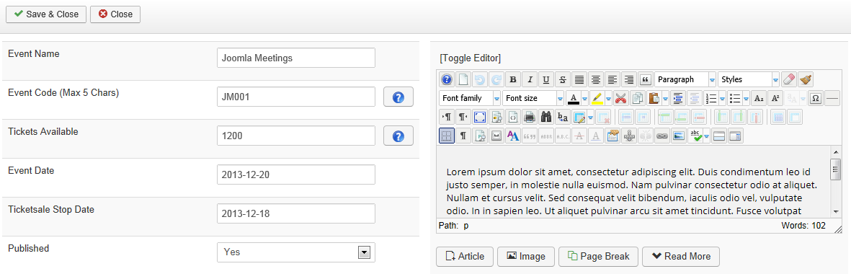

1. Enter a name in the “Event Name” inputbox.
2. Give up a event code, maximal of 5 characters. E.g.: B90S 🡨 The event is called Back to the 90’s (So this is corresponding well the event name and code needs to be clear to everybody)
3. The amount of available tickets. (Note: This is only used as indication, Ticketmaster is recalculating the tickets on every add of a ticket.
4. The event date, just click on the calendar near to the inputbox.
5. Ticket sale Stop Date; when needs the ticket sale to stop.
6. The information for the event, you may add HTML in this box and add everything you like as long as it is HTML.

When clicking the Save & Close button on the right top, the event will be saved.

# 3.0: Ticket Overview.

When clicking the Tickets button in the Control Panel / Top MEnu, you will be redirected to your Ticket Overview.

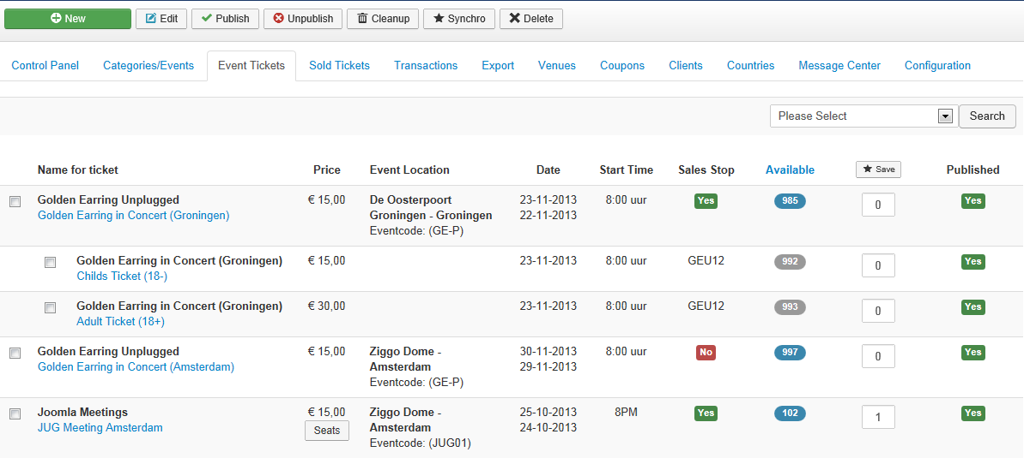

In the toolbar you will find the next items:   
  
 a: Publish & Unpublish for turning on and off some (child)tickets.   
 When turning off a parent tickets, the childs will also not be visible anymore in the frontend of your website.  
 b: Add & Edit buttons for adding and editing tickets.  
 c: Cleanup for cleaning up the database (unfinished orders will be deleted and checked.)   
 d: Synchro for synchronization actions (unconfirmed/paid orders (Settings can be set in the configuration))  
 e: Delete

### 3.0.1: Ordering your Tickets:

In the image on the next page you will have some input boxes below the red arrow, you may fill those boxes with the numbering you need/want and hit the save button directly below the red arrow. The ordering can be entered per event, so it is possible to have #1 twice in the ordering. The ordering of the Child tickets (black square) is being used in the event details page.

All other ordering is used in the event list screens.

### 3.0.2:Counting Tickets:

Below the blue arrow is a column named “Available”, here you can see how many tickets are available for an event. When a customer buys for example a child ticket from the Golden Earring Concert in Groningen, the Child Ticket and Parent Ticket will be decreased by 1. As soon as the available tickets is below 25 tickets, the icons turns on red color.

### 3.0.3: Synchronizing and Cleaning up Ticket counters:

As Ticketmaster uses a database driven counting system we have to remove unfinished and unconfirmed orders from your database. This way your ticket totals stays up to date, so you have to hit them once a day or more often if you like. What does the buttons do?

### 3.0.4: The Synchro Button:

The synchro button will delete unconfirmed orders from your database. They are visible in the backend, but the client or the system did not confirm them as there was no payment. These needs to be removed, in the configuration you can set the days when it needs to be removed.

You have set this to for example 2 days. When hitting the synchro button, it will delete all orders that are unconfirmed older than 2 days.

Automatic export on synchro. Sometimes you're not the owner of the site (you have built it for a client) and the client hits the synchro button before checking his order (Sold Tickets). There were a few order unconfirmed but paid and the customer wants them back...... That was not possible in earlier versions. Now the orders will be exported to Excel before synchronization. So you have always a proper backup.  
  
Read the FAQ for restoring orders from a backup! -- You can find it in the knowledgebase too!

### 3.0.5: The cleanup button:

The cleanup button can be used more often. This will remove order that never finished because a visitor left your site for example. There is no user account for this order and there is also no payment. As the user session expires after three hours you may use the button every 3 hours to delete unfinished tickets.

**Updated Cleanup in v2.5.4:**  
You can turn on to do this process fully automated. Go to the configuration screen and set the "Automatic Remove" to yes and choose the interval for removing. Save to use is when you delete this orders after 2 hours. You will be sure they are gone from your site.

**Updated Cleanup in 3.1.0:**  
We have more types of payment statuses in Ticketmaster since the last updates, the payment status will now be able to have the following status:

* Failed 🡪 No Payment at all came in.
* Pending 🡪 Customer paid by PayByCheck Plugin (still needs to pay)
* Paid 🡪 Order has been completed and paid.

In version 3.1.0 we have changed the tickets that needs to be removed, those who have payment failed and did not confirm their order will be removed after the amount of time you set in the Ticketmaster configuration:   
  
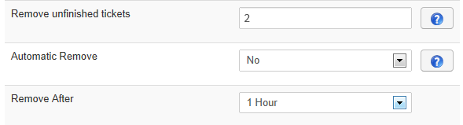

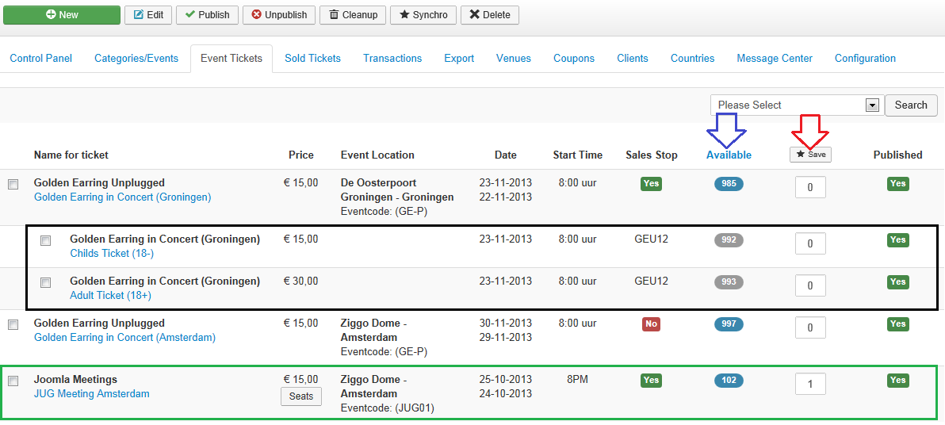

### 3.0.6: Parent & Child Tickets

When you have selected a ticket to be parent and a child (see the black square above), the child is visible in the frontend. If a tickets has no childs the parent (see the black square) will be shown. This is something you need know! For the sales stop we are using the main/parent ticket, if you have set a sale stopper there, all child tickets will also be stopped at the same time.

You can use the dropdown selection tool when you have lots of tickets in your component. EG: You do have 35 different tickets with child you can select the ticket you want. It will show your ticket with the childs.

## 3.1: Add & Edit tickets

In the previous screens you have seen a set of tickets, let’s see how to add a ticket to your system.  
There are just a few items you have to remember and to know before adding a ticket.  
First of all you have the ability to copy ticket data from other events, some people do have have multiple tickets for one event and they need to enter the same data often. You may select an event in the red square and the data will be loaded automatically and will fill the most boxes if possible.

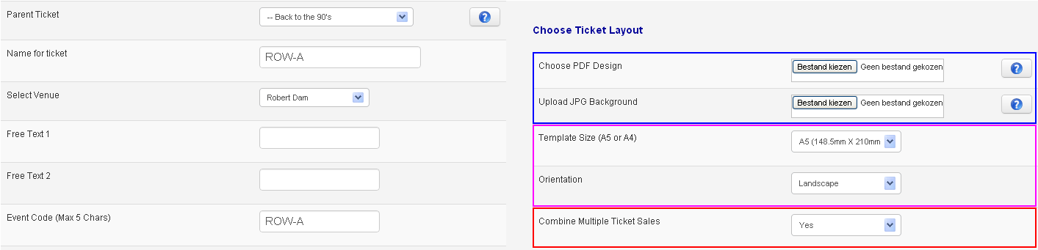

### 3.1.1: Choosing a different design for every ticket you enter.

**\*\* Blue Square:**   
Something that was pretty often requested is availability of a different PDF ticket for every event you’re entering. You can upload your own PDF files now. Note; There are no restrictions on the size of the PDF, the only restriction is the server. But keep in mind that the tickets will be sent by email. So don’t make them to big as some people do have a restriction on the mailbox size. *(Note: If you’re not uploading a PDF file the default ticket provided by Ticketmaster will be used)*

By uploading a JPG file as background, you are forcing the component to use this background. The component will not check if there is a PDF file anymore, but it has dtected the JG file and will use this one in the Ticket. Note: Make sure your JPG file has the correct dimensions,

**\*\* Purple Square**  
You may choose which template size and orientation you would like. (Only available in Ticketmaster 2.5.5 or higher) You may choose to use A4 or A5 formatting in Landscape or Portrait orientation.

**\*\* Red Square:**  
When you have installed Ticktmaster 2.5.5 or higher, you have the possebillity to combine tickets into one PDF. For example; when a customer has bougth 5 tickets he will receive attachments in his email and order email. Now you may choose per ticket to combine the tickets into one PDF. When the tickets will be sent to your customer it will combine all tickets into one PDF and sends them to the custmer.

**Important to know:**  
When you have created a ticket in Photshop or whatever, you must consider the size of the JPG/PDF file. Example: A client that orders 10 tickets and the ticketsize (when saving it) is 1MB, the client will receive 10MB as attachment, not all providers do accept this.

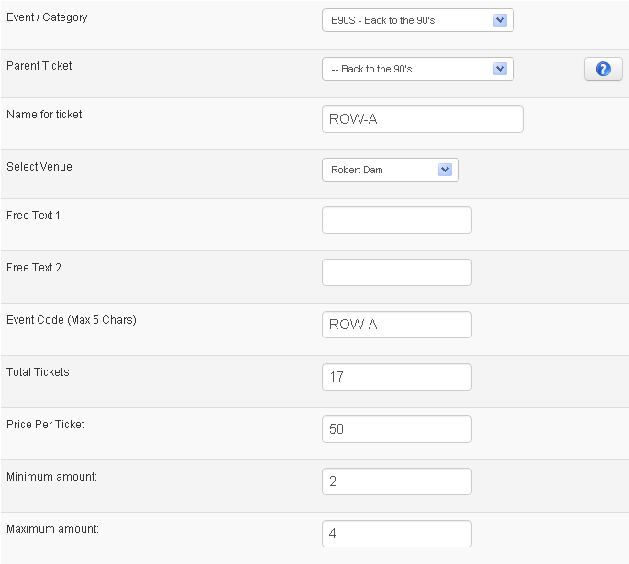

### 3.1.2: Main Ticket information:

In the first dropdown menu you may choose the event / category.

If this is a child ticket you need to choose a parent for this ticket, if not then you may leave the Parent ticket to Parent and it will become a parent.

The name for the Ticket and the Venue are pretty clear I think.

If you are filling the Free Text 1 & 2 they will show up on your tickets. So these boxes are not visible in your website but will only appear on the ticket if filled!

The Event Code is printed on your tickets and visible in the frontend too. Make sure you have the code clear for you and the customer. (EG: Eventname: Back to the 90’s 🡪 Event code: B90S)

*\*\* As you can see everywhere through the component you will see the ? (button) By clicking the ? button a modal will popup with extra information about the input box and information about this function.*

**Total Tickets:** The amount of available tickets for this event. If you have the PRO version installed we are not looking/verifiying if you are adding to many or to less tickets. In our case ROW-A may have 17 tickets.

Price Per Ticket: This is the price per ticket.

**Minimum or Maximum Amount;** I you are seling tickets, you sometimes want to have a limitation on the amount of tickets per customer. You may choose to set a minimum and maximum amount per ticket per client. In this example it is a minimum of 2 tickets and a maximum of 4 tickets per customer. He will see the following thing in the frontend:

This rows will not be shown when you haven’t turned it on. You can disable the functionality by leaving the minimum and maximum boxes empty. What I see too often is that you set the minimum 1? The scripts knows that the minimum order is always 1, otherwise you cannot add tickets ☺

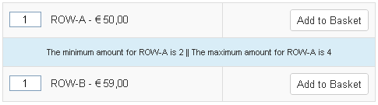

### 3.1.3: Setting Time and Date for your events:

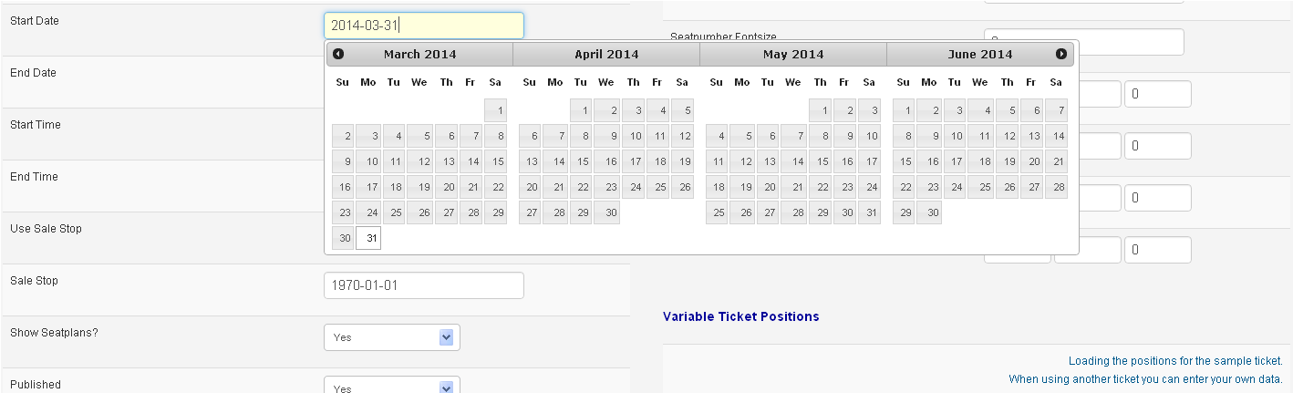

You will have the choice to create and manage start and end dates, a starting time and this will all be printed on the tickets. It’s doesn’t need much explanation I think.

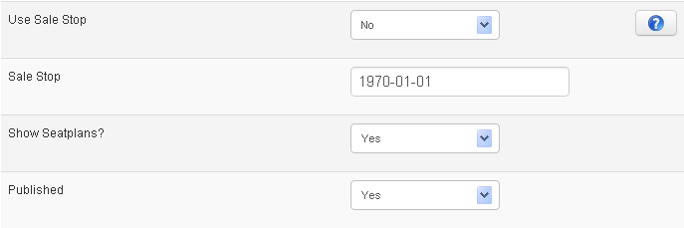

If you have installed our TicketStopper Plugin, you may set “Use Sale Stop” to Yes (If you haven’t installed it, it is useless) And you need to set a sale stop date in the date picker. Otherwise it will be stopped immediately as 1970 has been passed already ☺

Showing seat plans will only show up when you have the Ticketmaster Pro Installed.

### 3.1.4: Variable Ticket Positions:

We have created a preloading dataset, this may be loaded if you like. When you want to load default ticket positions, you may click the text: “Loading the positions for the sample Ticket”

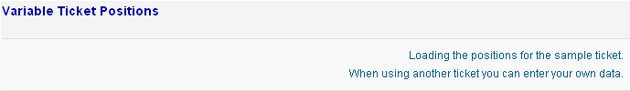

But if you want to enter your own values, you can set the values yourself. We have a screenshot below:

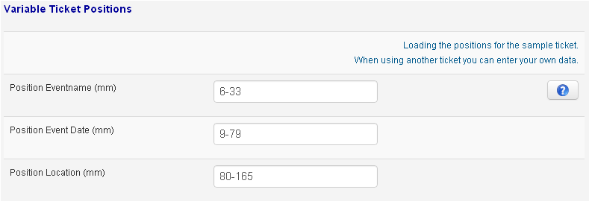

When you want to choose the position of the textures, make sure you have the ticket near you. (Photoshop is OK!)  
The position needs to be filled for example: 6-33.   
We use this in x-y combinations. 6-33 is 6 mm from the left of the document and 33 mm from the top. During the PDF creation we will explode this setting and use this values for printing the text on the right position. When you don't enter values, everything will be printed on the left upper corner.

To make the positions the right way, you need to use Photoshop or Illustrator. **FPDF is not supporting created PDF files created by a PDF Creator for example!**



[](http://en.wikipedia.org/wiki/File:UPC-A-036000291452.png)You may choose per ticket what to barcode you want to use, 1D is the normal barcode like on CocaCola bottles. (It’s the barcode on top) The other option is a QR Code, you will see it more often now a days. So you may add these to your tickets too!

### 3.1.5: Overriding the PDF creator.

[](http://en.wikipedia.org/wiki/File:Wikipedia_mobile_en.svg)It’s also possible to override the entire file so you can make add-ons to the creator without losing data when upgrading the component to a newer version. During the creation of the PDF the script will check if there is an override file, if there is one it will be used to create the PDF file.

The original PDF creator is located here: [root]/administrator/components/com_ticketmaster/classes/createticket.class.php  
When you create an override you have to do the following steps:

* Create a folder in the classes folder, named: override
* Copy the createticket.class.php file
* Paste it in the override folder.

The scripts are now using your override file. You can change it the way you like.

### 3.1.6: Ticket Totals & The Ticket Counter.

The ticket counters are pretty special, with the update to Ticketmaster 3.1.0 (will be released in September 2013) you may choose which ticket counter you will be using to show sold out tickets.

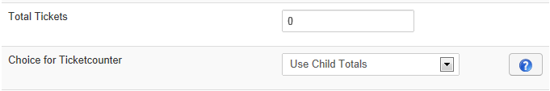

When you enter a ticket in Ticketmaster, you will see the above option in the left column. You can set the total amount of tickets which is pretty clear. But by default Ticketmaster will count tickets from the parent ticket. (If there is one, otherwise the ticket you are entering is a parent)

**EG 1: Ticket counter based on the parent.**  
  
For some events you can have a variety of tickets and the total amount of visitors may be 1000. It doesn’t matter if it are childs or parents or whatever.

So, in the above case you want to show availability based on the parent Ticket.. If the parent is out of availability you can’t register anymore for the event. In this case you could have 750 adults at your party and 250 childs. (makes 1000).   
It will show sold out for all child tickets as the maximum amount of tickets has been reached.

In the screenshot below, you can see that the Parent Ticket is sold and everything is sold out

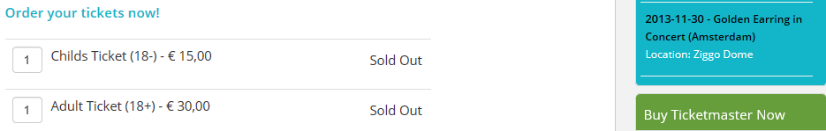

**EG 2: Ticket counter based on the child.**

In other cases you don’t want more than x tickets for a specific child tickets. (because you have seats or something like that) But you do want more than one child tickets. You may choose to set the counter by ticket child ticket. This way the child tickets may run out of tickets but it will only be one that may be sold out then. Others are still available.

In the screenshot below, you can see that the Child Ticket is sold out and the Adult Ticket is still available:

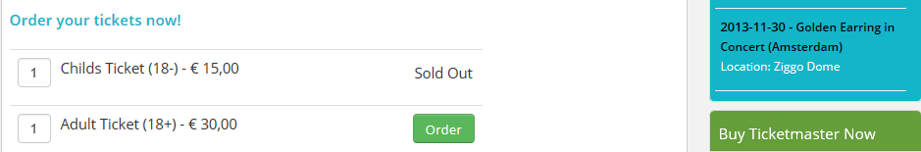

## 3.2: Ticket information and the PDF File.

I hope the image below makes the different, here you can see what inputbox is connected to the PDF and how.  
The first part of the image is the screen you saw in chapter 3.1 and the second part is a screenshot of the main eTicket file.

## The barcode is generated automatically. You don’t have to do anything for this.

Many of the information entered in the ticket (while adding a ticket) is being used on the ticket PDF. Make sure all data is correctly before selling tickets. There are many settings in the component, so be sure everything is set the right way.

# 4: Sold tickets in Ticketmaster.

After you have set up the categories and their tickets (and the configuration of course) you can start selling tickets to your website. We have a view created to view all orders, confirmed, unconfirmed, paid or unpaid and so on.  
After you have sold your first tickets, it will show up like below.

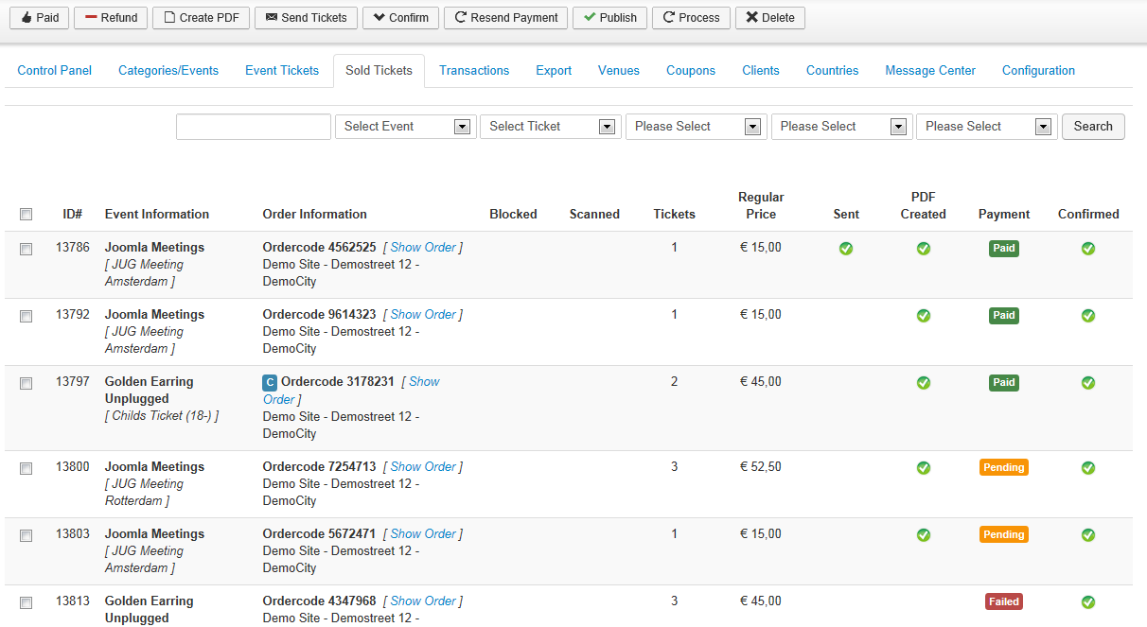

* Overview of sold tickets with their main information (Event, Order Information, Is it scanned/blacklisted?, Price) The main information about the order will be visible.   
    
  a. Order 3178231 (ID# 13797) has a blue C in front of the ordercode, this means that the customer has added a  
   coupon code. To see the used coupon you need to click “Show Order”   
  b. A payment can have different statuses:   
   - Paid: The customer has processed the payment.  
   - Pending: This status can only be set by the PayByCheck plugin. It is waiting for the payment.  
   - Failed: The customer tried to checkout, but the did not complete a payment at all.  
   - Refunded: Customer has requested a refund. (If this is the case, then please disable the tickets too!)
* Advanced search, you have multiple selectors that maybe changed to find the order you´re discussing.
* Unordered list of orders, why unordered? When a customer orders 5 tickets, you will only see the first numbers.
* Direct link to the order, you can see the specification of the order. *[Show Order] (🡪 Link to the order Details)*
* Toolbar of functionality.  
   A: Paid: Select some orders in the overview (See #1) and click Paid. The orders will be set to paid.  
   B: Create: when an order is confirmed and paid, you select them and hit the create button to create the PDF’s  
   C: Send: Select a bunch of confirmed, paid and created tickets and you can send them in a batch.  
   D: Confirm: Client wants a confirmation of his order. Just select the order and confirm it by email.  
   E: Publish: Set some orders to confirmed, just select and publish them so the customer has not to do   
   this anymore.  
   F: Process: see the details of an order with client details.  
   G: Delete: Select some items and hit delete, the order will be deleted and tickets will be counted again.

### 4.0.1: Resend Payment:

Added in Ticketmaster: v3.0.2  
  
When you select some tickets by the checkbox, you will be able to resend the payment request to a customer. You should only do this to orders with the payment status “Pending” or “Failed”. The customer will receive an email to make the payment online. As we know exactly which order it and which customer is affected, the link in the email* is being redirected to the cart overview again. Customer can login, see the payment options and is able to make the payment. After the payment came in the order status will also change directly to payment status: “Paid”

*\* Example email can be found in the email chapter.*

## 4.1: Showing the order details.

When a client has registered on your site, and did an order you can see it. As described above in the “Sold Ticket Overview” you can see a lot in that view. But you can also see the details of an order. Then you see the missing numbers as described above.

Click “Show Order” in the sold ticket overview to see the details of an order.

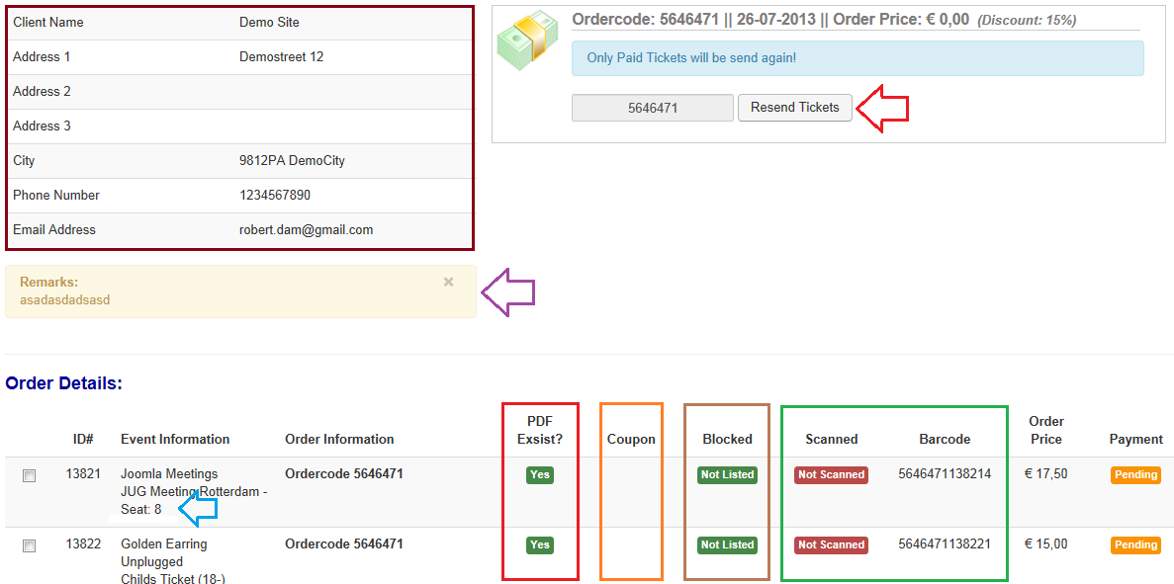

You can see the details of an order above, client information (brown square), order information and a list of ordered tickets. At the bottom of the page. (overview of orders within this order)

### 4.1.0: Order Details:

The red square gives you an indication if these tickets are on the server. If not, you have to recreate them before sending.   
The orange square indicates if a coupon is used.  
The green square shows if the ticket is blocked or not.  
The green square shows if the ticket has been scanned and the created barcode with this ticket.

Functionality of the buttons in the toolbar:  
  


Before you can use the buttons you have to select items in the ticket overview to perform actions with the buttons.

* Paid / Unpaid: Set a specific ticket of this order to paid or unpaid.
* Block / Unblock: When you use a scanner it will scan the ticket and the component is giving back the status blocked if you have blocked a ticket for entry. (codeREADr has this functionality with our API.
* Close for closing this page and return to the overview.

Another option of this screen is sending tickets again, sometimes customers lose their tickets and you need to send them again. The red arrow is clickable to resend the tickets to your customer. NOTE: The tickets MUST have status PAID and must exists on the server (the red square)

### 4.1.1: Remarks on order:

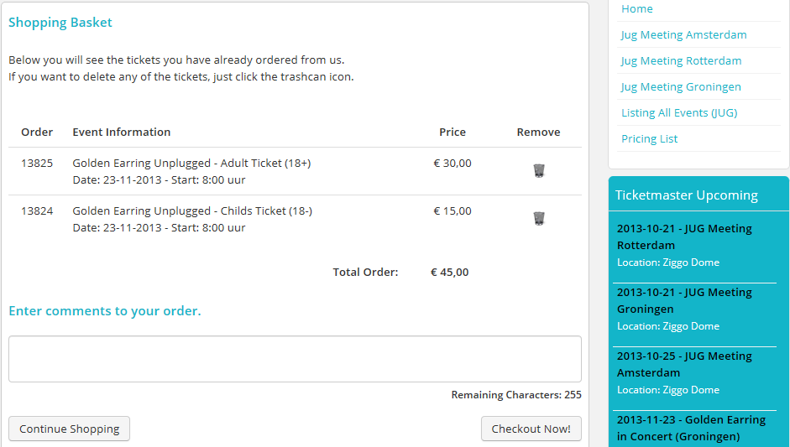  
If you customer has filled remarks during the order, the remark will be shown near to the purple arrow. If there are no remarks, nothing will show up there. (the remarks are being entered when the customer is in the Cart Overview / Shopping Basket. (see image below) (Maximum input for customers is 255 characters)

In the export of the tickets all remarks are also shown, so you can export and in the extra column you will see the remark of the customer.

In the screenshot on the right side you will see an example of the remarks system. You may turn this option on and off in the Ticketmaster configuration.

### 4.1.2: Ticketmaster Pro & Seatnumbers:

As soon as you have installed Ticketmaster PRO for seat bookings, you can see the seat number in this overview. You can see it near to the blue arrow. (See the screenshot below in the column Event Information)

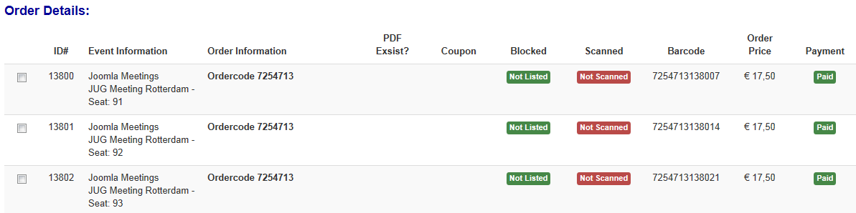

# 5.0: Ticketmaster Message Center.

We have a special message center created in version 1.0.13 and Joomla 1.6 version. With this functionality we are offering you complete flexibility to show special pages for events, payment processors and email messages.  
Where we had only email templates before, there is now some special pages and this functionality will only being extended as there are many options with this system.  
  
Let’s take the first looks of this system:

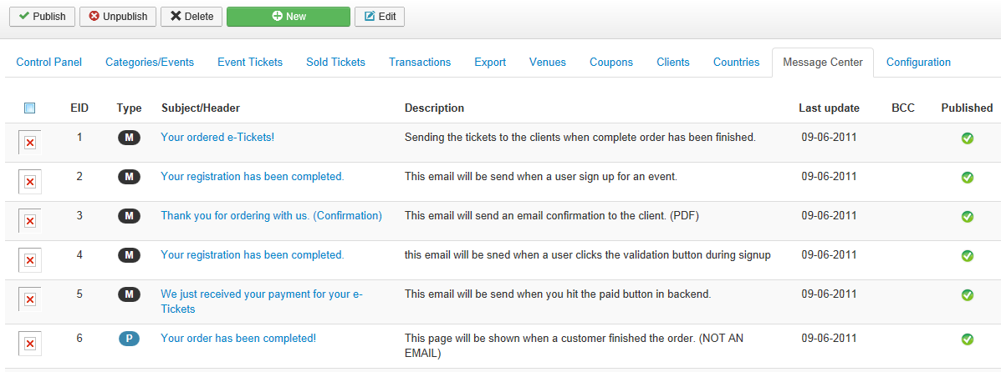

Here is an overview of all your messages and their functionality. Let’s start on the left side of the page.  
  
**Checkboxes**, with a special function. Some are disabled, why? We have chosen to disable the standard used templates as these are needed in the system. So you can’t delete them, only by PHPMyAdmin. But then it’s your own decision as an administrator.  
  
When you have deleted them you need to add them again on the same place in the database. So, please don’t delete them. We cannot guarantee anymore if you have deleted them!

**Template Type**, as we have enabled plugins to handle your payments, we do need variable pages (EG: Mollie, Ideal, PayPal and all other processor to have their own page to return success or failed payments. This way you can do it! If you don’t add any special plugins, you don’t have to add pages/templates. You can read on activation in the plugin part of this documentation.

**Receive BCC**, with this function you can turn on BCC sending of emails per template. In earlier versions of Ticketmaster you had one BCC for all. But some of you wanted them to be turned on and off. *(Functionality added in version 1.0.13 and version Joomla 1.6 versions, not possible in all previous versions)*

**Published**, this is a main functionality of Joomla but we have changed the scope a little. With this functionality you can turn on messaging for all templates. So if you don’t want to send the tickets, then you just unpublished the template and it won’t be sent anymore. *(You need to very sure as we are not storing any mails into database, maybe later on as mail queue!)*

**Pre reversed: Message ID 50-250 for Ticketmaster system messages.   
Own messages will start at Message ID: 251**

## 5.1: Add message to Ticketmaster Message Center.

We have tried to make this as easy as possible. Below you can see the edit/add screen to add or edit messages. Note: There are also system messages, these hava lock instead of checkbox. These messages are being used by the system and may not be deleted. You can simply write HTML text messages, which are being used in email messages and text pages.

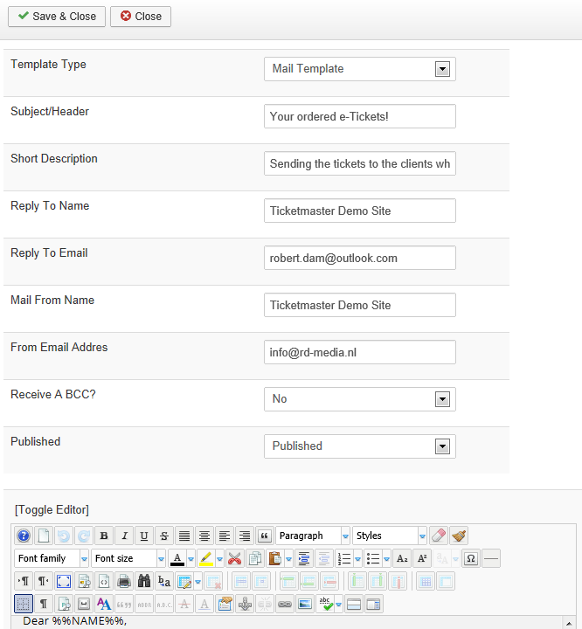

Description of the fields:

* **Template type:** Mail or Page template
* **Subject/Pagetitle:** you can set the page title and or subject of the email.
* **Internal Description:** this is only being used for you to describe what the template is doing for you.
* **Email Setting (4 fields):** Looks like you can set everything per email, that’s correct.
* **Receive BCC:** Do you want to receive a BCC email for this email?
* **Published:** Normally set to yes. Secured items are published!
* **Mail/Page body:** This is the HTML body for the mail or template.

**Notes;**

* A page template cannot have a BCC, you can turn it on or off but has no effect!
* When choosing the BCC set to on, the BCC will be sent to the reply to email address.  
  As this is also the email address where customers will sent replies to.

# 6: Venue Manager

The venue manager will allow you to manage your venues, this way you don’t have to enter them over and over and over. Note that every event needs a venue. Otherwise it will not be shown!

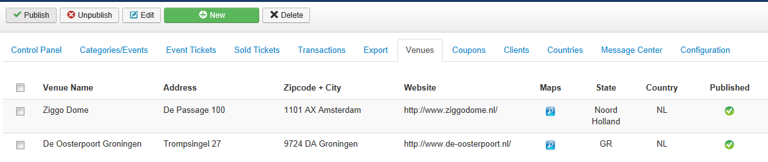  
  
The management screens has the main Joomla functionalities like; publish, edit, add and delete. We don’t explain what these buttons are doing there. If you still don’t know it, please read the Joomla docs first then.

Google Maps: The icon below the Maps text, can be clicked to check if the correct Latitude and Longitude from Google are used. The system checks if it can find the information from Google and saves the Long/Lat information. Please check and correct if you have a better Lat/Long position.

## 6.1: Add/Edit Venues

Before you can do anything in Ticketmaster you will have to add some venues to your system, otherwise events and tickets will NOT be shown to your customers.

The information that needs to be filled looks pretty clear. You can enter some data for the venue:

* Venue Name
* Address
* Zipcode/Postcode
* City
* Country
* Website
* Show Google Maps

The longitude and latitude from Google will be filled by the script. You don’t have to fill anything there. The script will detect where needs to point that pointer within the Google Map.

### 6.1.0 Google Maps

The pointer will not be placed by the component, but the Google API is chosing the location that will be viewed. Sometimes, the location is not exactly what you like or you would like it a bit more to the right or the left. If you set “Use own Longitude & Latitude” to Yes, the Ticketmaster scripts are quitting the automated Google position but will save your exact location to the database.

To let Ticketmaster do the search for the correct position you need to have CURL enabled on your server. Without CURL enabled the search will not be performed by Ticketmaster and no data will be shown then. You have to add the data yourself.

In the Global Joomla configuration, you can see in the TAB PHP Information if CURL is enabled. (90% of the hosters has CURL turned on as it is a default PHP function)

# 7: Export Manager

Exporting your data to an Excel Sheet. We have tried lots of management tools here, and the most easy one for everyone is an export that will really export everything. All data from the database is being pushed into an excel file.   
As stated in the red text on the bottom:

**!! You're exporting raw database data.   
Explanation: 0 = No and 1 = Yes. Example: Paid is having the value 0, then it's not paid !!**

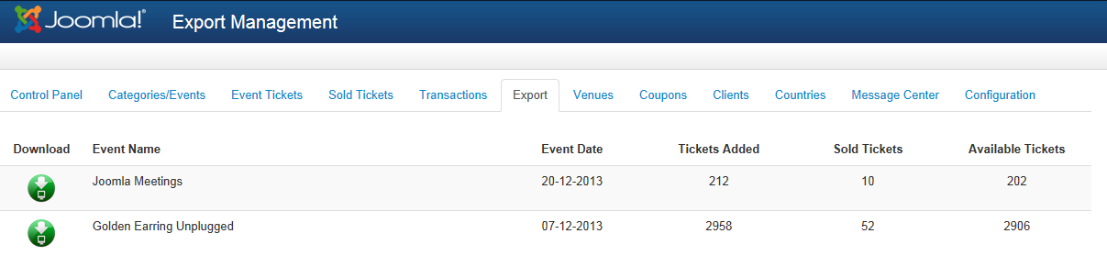

Example 1:

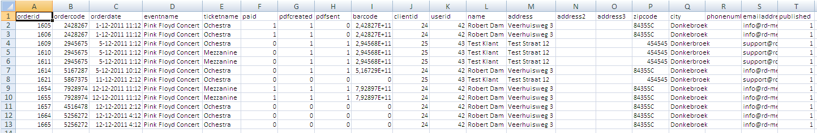

Example 2:

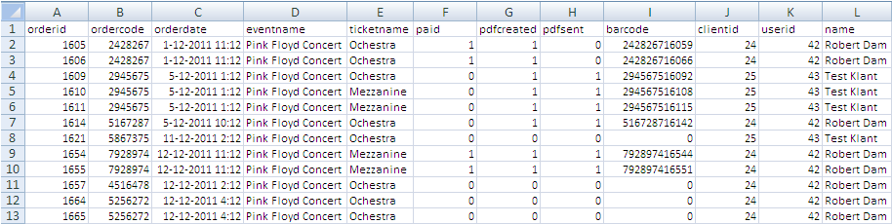

As you can see in example 1, excel is making something very strange of the barcode. The numbers are to long and excel is cutting them off. You need to change the settings of the cells to a phone number in order to see the data properly. So the complete column I (barcode) can be set to phone number.

In example 2 (you can see it again below):

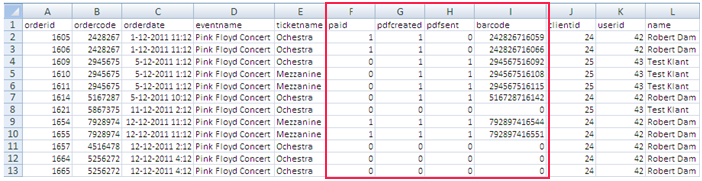

Not all barcodes have been generated, a barcode will only be generated when the PDF will be created. (Back or Frontend) .

**Let’s take ordered 1605 as example:**

Order has been placed at 1-12-2011, has been paid and PDF has been generated. As you can see pdfsent = 0, so it has not been sent.

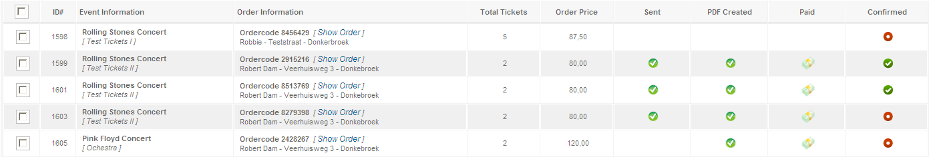

# 7: You Clients/Visitors

The most important of your component: clients!  
  
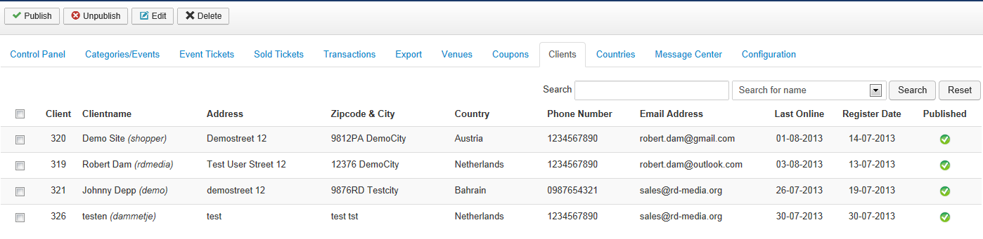

We’re storing all kind of information during the signup, and storing it in the database. In the overview above you have all client data as an overview. Details can be viewed when hitting the edit button.

When you unpublished a client ID, the customer is not being blocked by the Joomla Login, so you have to do this manually. Even removing customers won’t affect the Joomla user database, it is being removed from the component database and the orders will become invisible, but they are still able to login to your website.

## 7.1: Client Details

In the edit screen of the customer you can edit his/her details and you can see an overview of the orders this client has done in the past. When clicking the link in the order history you will be navigating to this order. This could be helpful when a client is calling you with questions regarding his order.

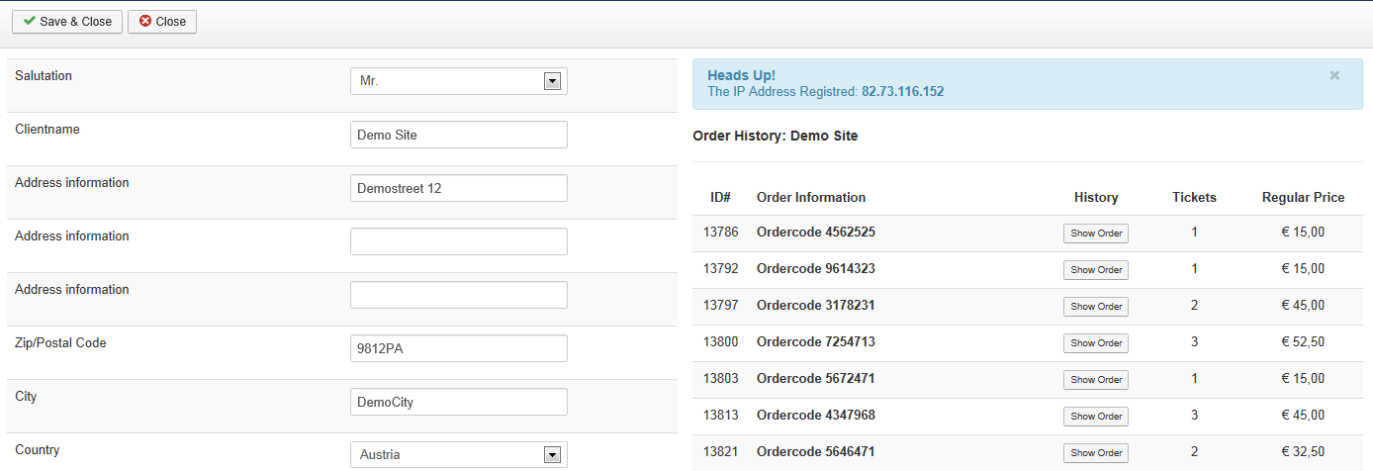

### 7.1.0: IP Address:

During the order process in the frontend we’re tracking the IP address of the customer that is making an order at your website. In the past there were some bots ordering tickets and or funny people who like to click all buttons in your website. If this is happening you may be able to track their IP address in the order table and block them by some useful plugins created for Joomla or a simple htaccess file.

### 7.1.1: How to track happy clickers in your database?

As stated in the chapter 7.1.0, you have funny people clicking around in your website and ordering lots of tickets, so you have to use the cleanup again and again and again.. Getting crazy? Let’s block this IP and stop giving him access.

* Open your PHP MyAdmin (the database) and go to the database which is being used by your website.
* Go to the table #__ticketmaster_orders (replace #__ with your own prefix)
* On the right of the table (the most right column at the moment) you will find an IP Address:

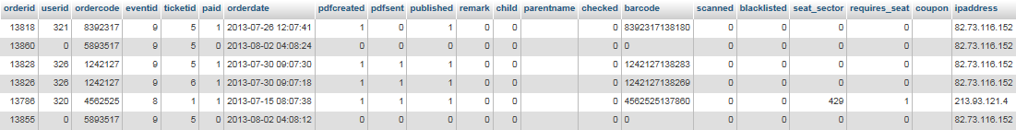

If you find the same IP often or to to often, then you can decide to block this user by IP.  
[**http://www.htaccess-guide.com/deny-visitors-by-ip-address/**](http://www.htaccess-guide.com/deny-visitors-by-ip-address/)

I am sending you to the PHp MyAdmin environment as not all orders are being processed, mostly these guys/girls stops when they have to register. The cleanup should also work, but if you tired of clicking around, just block them ☺

# 8.0 Countries in Ticketmaster

You will have ability to let the customers select a country during signup. In the country manager you will be able to choose which countries will be shown during the signup. By default Ticketmaster is being installed with all available countries all over the world. But if you need only a few countries you may unpublish them. (or remove them) Or maybe you want to replace them with a province or something like that. It is possible in the country manager.

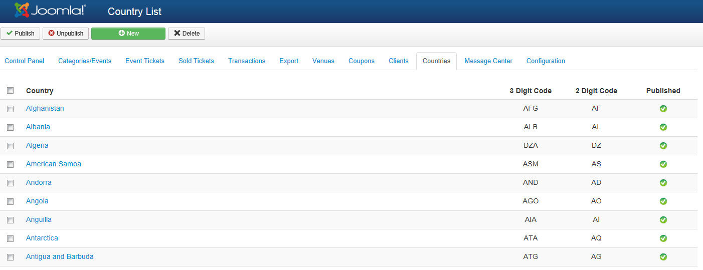

## 8.1: Edit a country in Ticketmaster.

Editing a country has not a lot of options, more the basic things. I think when you see it you will know enough ☺

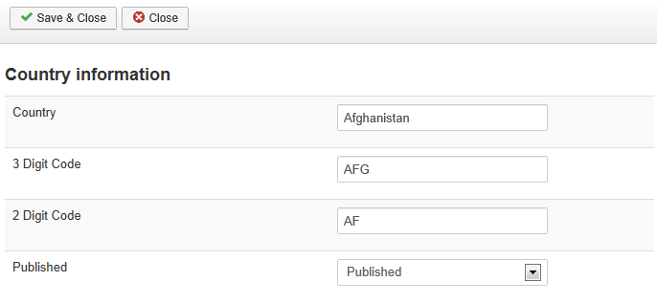

# 9.0 Coupon Management.

In Ticketmaster we have the ability to make unlimited coupons for checkout. The coupon manager is pretty flexible, you can set the next features to a coupon.

* Coupon Code 🡪 Being used by your customer, only capital letters and numbers allowed
* Coupon Limit 🡪 Example when you are giving one person a coupon, it can be used once.
* Expiry date 🡪 The coupon(s) can be used till this specific date.
* Percentage / Fixed Discount
* Coupon Amount

A coupon can be entered by a customer when you have it turned on in the Ticketmaster configuration and it will be visible in the cart overview of the order (see screenshot below)

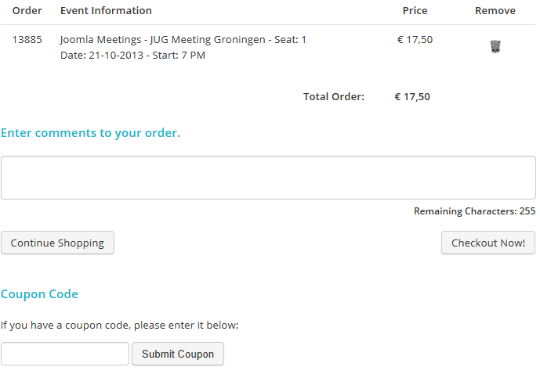

They enter the coupon code at the bottom of the screenshot and if the coupon is valid, it will be applied to the cart. Also when customers decides to buy more tickets, Ticketmaster will apply the code that has been entered already immediately to the newly added ticket.

And if the coupon has been applied and the surf on the checkout pages, the will see it like this:

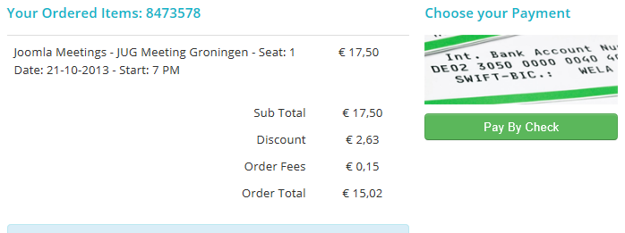

## 9.1 Adding coupons to your system:

Adding a coupon is pretty easy and can be done by everybody:

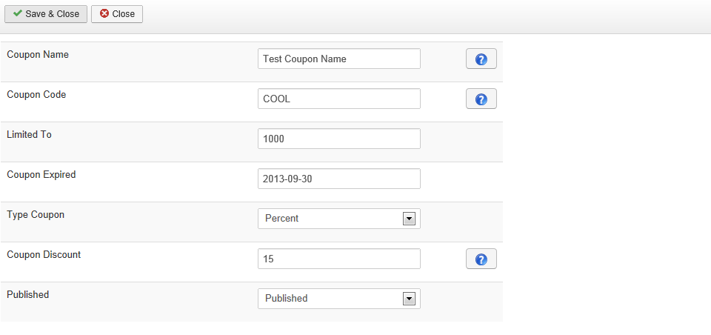

* Give the coupon a valid name for your own administration.
* Set up the Coupon Code:  
  - UPPERCASE CHARACTERS ONLY  
  - Numbers are valid between 0-9
* Setting a usage limit. (Currently unlimited is not possible)
* Setting the expire date for the coupon.
* Coupon Type: Percent/Fixed amount
* Setting the discount, if you set 15 like above it will be 15% discount.
* Publishing state.

# 10.0 Ticketmaster Configuration

There are many settings within Ticketmaster and we know that is has a learning curve, but as soon as you have set it up the right way it will run like a train! 80% Of the configurations option will be discussed below:

## 10.1: Template settings

Responsive is hot at the moment, so you will have the choice what you would like to load. We have bootstrapped themes and non-bootstrapped themes. In the template settings you may choose the what you like to use:

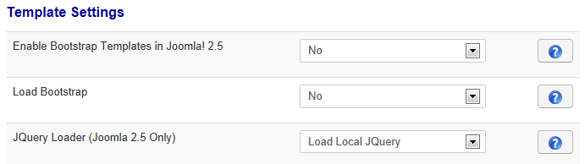

* **Enable Bootstrap in Joomla 2.5 templates:**  
  Yes, it is possible, we are going to load the bootstrap in your website then, but be careful! If you running a template with preconfigured grids then the 2 css files may conflict and you get weirs results. You can always test to see what is happening, the bootstrap templates are nicer to see ☺
* **Load Bootstrap:**If your template has bootstrap you may set this to no otherwise if you have enabled the bootstrap it must be yes otherwise the CSS markup is gone.
* **JQuery Loader:**Choose where you want to load the JQuery library. Some people have their own CDN, so the want to load their own JQuery version. Note; that we support this. If the component is working with local JQuery and not with your own CDN, this will your own problem.

## 10.2: Payment options.

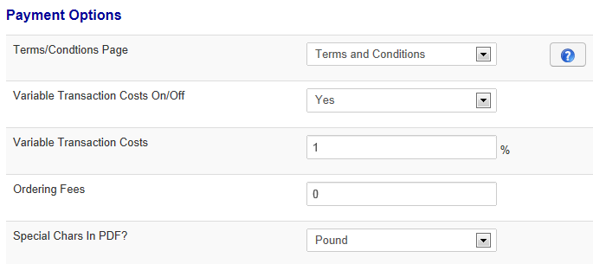

* **Terms/Condition Page**Create a message In the message center (menu item “Message”) or change ID#13 or #50.   
  During checkout the customer can click to accept terms and conditions, this page will pop up in a light box.
* **Variable Transaction Costs On/Off – Variable Transaction Costs / Ordering Fees**The ordering fees are special in Ticketmaster and you have to know exactly what you are doing. Follow the rules below and you get exactly what you want:  
  ticketmaster is always counting the “Fixed” Ordering Fees, when you have turned on this option it will count the Ordering Fees + Variable Fees. Let’s give you an example on the above setting:   
    
  * The total amount of ordered Tickets is: $ 100.00   
  * Variable Transaction Fees is: 1% so the total amount will become: $ 101.00  
    
  If you have set the Ordering Fees to $ 5.00 for example:  
    
  * The total amount of ordered Tickets is: $ 100.00   
  * Variable Transaction Fees is: 1% so the total amount will become: $ 101.00  
  * With the extra $ 5.00 fees the total will become: $ 106.00
* **Special Characters in PDF?**By default PHP in combination with FPDF doesn’t know some special characters, these needs to be coded separately. When you are using Pound Sterling (UK) or EURO (European Union) You may set additional characters in the the PDF file.

## 10.3: Main Component Settings:

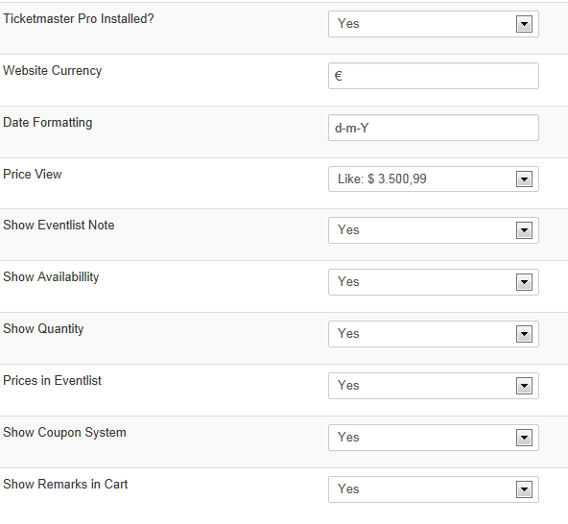  
 Most of the features are pretty clear to most of you so we do not discuss them all.

If you have Ticketmaster PRO installed, set this dropdown menu to YES. It will show additional options while adding tickets.

Website Currency & Date Formatting, please set it to the conditions you like. For date formatting you may take a look at <http://php.net>

The price view, you have a variety of choies how the prices should look like on your website, play around and see what is the best one for you. If you are missing any, just send us an email.

Showing Availability & Quantity; you may choose if you want to show them in the frontend of your website.

Do you want to enable the Coupon system yes or no, if you have turned it on below the cart page an extra form will show up for your customers to add coupons to their order. (more information in chapter 9)

And last but not least, do you want to enable the remarks system? An additional field will show up to enter a 255 characters inputbox for remarks that can be filled by your customers.   
(more information can be found in chapter 4.1.1)

## 10.4 Email Settings.

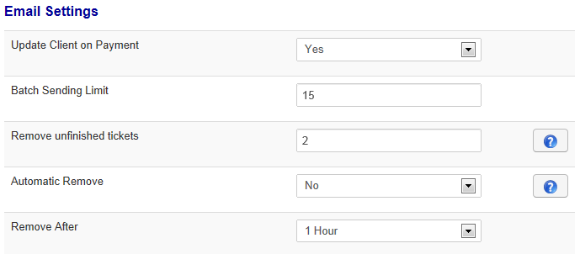

* **Update Client on Payment:**  
  In the toolbar of the sold orders page ***(see chapter 4)*** you will have the ability to update an order to the status Paid. If you have turned this feature on, your customer will receive an email that his payment has been processed manually. (Message ID #5 will be sent in this case)
* **Batch Sending Limits:**This functionality is almost not used anymore, when turning on cronjobs to process orders automatically you can set the limit per batch here. Nowadays all customers pay by a payment plugin so these will be processed immediately. No need to have a cronjob then.
* **Remove Unfinished Tickets:**  
  After how many days should we remove the ordered tickets? Customers that are choosing to Pay By Check or where the payment failed have an x amount of days to pay their order otherwise the component will release the tickets to the audience again. Set the number of days (3 by default) ***(Read also: Chapter 4.0.1 & 3.0.4 and 3.0.5)***
* **Automatic Remove:**The name of the function probably says enough?
* **Remove After:**Ticketmaster uses a different session then a webshop as we are dealing with real-time sales, so when a customer orders a ticket it will be registered in the database immediately with a session number for that order. This session number is being used everywhere. But when the client doesn’t checkout at all the ticket is still registered and the counters has been decreased. Please install the Ticketmaster Cleaning plugin and set the amount of hours in this box. In the screenshot above the unfinished tickets will be removed by the plugin if the order is one hour old and not paid.

## 10.5 Event Page Settings

The event page contains some information that you may want to hide. 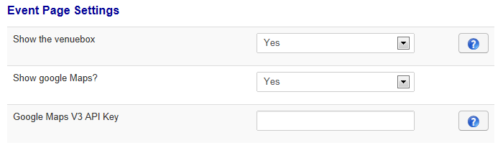

Do you want to show information about the venue? Yes/No  
Do you want to show Google Maps: Yes/No ?  
  
**If you have set Show Google Maps to YES:**  
Obtain a Google Maps Key, we refer to the knowledgebase item in this one:  
<http://rd-media.org/support/knowledgebase/view-article/67-sign-up-for-a-google-maps-api-key-3-0-2.html>

## 10.6: Checkout Settings

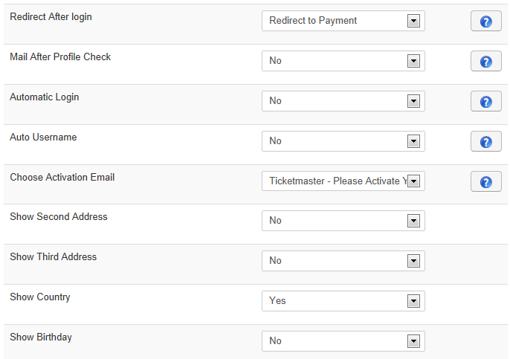

* **Redirect After Login:**  
  When a client checks out and he has an account already in your database, you may want to redirect the customer immediately to the checkout/payment pages. You can set this option here.   
  **Choice:** Redirect to Payment or Redirect to Profile Pages  
  If the profile is missing and you have set this option to Redirect to Payment, the component forces the customer to enter a profile before going to the payment pages.
* **Mail After Profile Check:**  
  By default we have set this to NO. You may want to send an email after updating the account but a customer gets lots of email during the registration and so on. So we advise you to turn of this email.
* **Automatic Login:**  
  When the customer is creating an account with your website and he has filled out the registration form you probably don’t want him to enter his username and password again for logging in. So when this functionality has been turned on he will be logged in immediately after creating an account with your website. ***(Read Chapter 11 for required additional settings)***
* **Auto Username:**   
  Ticketmaster will be able to choose the login name for you customers based on the email address. So when turning this option on, the email address will become the username.
* **Choose Activation Email:**  
  Choosing a custom email to be sent with login information for your customer, you may read more about the messages in the messages chapter (5). An example email is listed in Chapter 12.
* **Show Second & Third Address:**  
  Don’t need any explanation.
* **Show Country:**  
  Show country choice during signup.
* **Show Birthday:**  
  Showing birthday entry.

## 10.7: PDF Settings

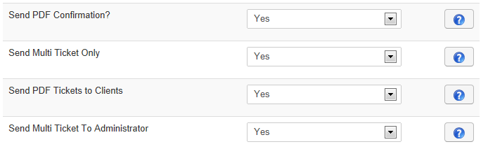

Since the release of Ticketmaster 3.0.2 you have the choice to send out different types of Tickets.

* **Send PDF Confirmation?**  
  Do you want to send your customers a PDF confirmation. The PDF confirmation contains data about the order they have placed and the payment status of their order.
* **Send Multi Ticket Only**  
  The multi ticket became new in Ticketmaster version 3.0.3. All tickets will be combined into 1 A4, no spectacular ticket, but listing all information with a barcode. Only a header is possible, as background image and the rest is created dynamically based on the ticket information and order information.  
  NOTE: When you select to send out Multi Tickets only the normal Tickets are not being created!
* **Send PDF Ticket to client:**  
  In version 3.0.3 it became possible to turn off PDF sending as not everybody needed this functionality. The email is being sent when published in the backend but no attachment (PDF) is being added.
* **Send Multi Ticket Ticket to Administrator:**  
  It was requested often and in Ticketmaster 3.0.3 it is possible! You can see this as a confirmation to the Administrator. And will be sent in a separate email to the administrator of the website. It contains all data like in the Multi Ticket but it will only be sent as confirmation to the administrator.

# 11: Turning Off the Activation email.

This has nothing to do with Ticketmaster, but it is important to know for some people. By default Joomla has turned on account activation when signing up by the any registration form. In our case the flow would be like this then:

* Customer is choosing their ticket.
* Goes to shopping basket
* Fill out your registration form
* Wait for the activation email.
* Activates the account
* Make Payment
* Done..

**Wouldn’t it be more easy for your customers to have it this way:**

* Customer is choosing their ticket.
* Goes to shopping basket
* Fill out your registration form
* Login to your website
* Make Payment
* Done..

Follow the next steps to turn off the activation:

Go to the Joomla user manager and hit the options button in the toolbar:

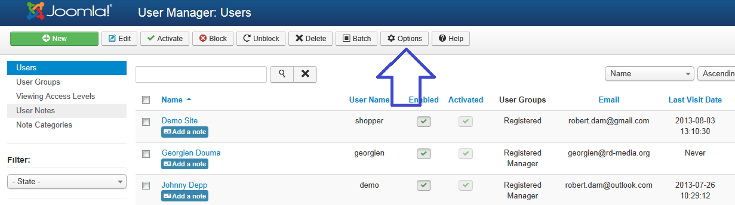

After you have clicked the options button a new screen will appear:

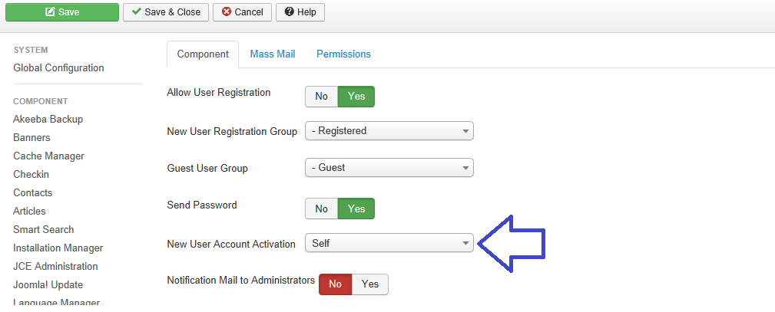

Set new user activation to “none” 🡪 Registration will take place immediately and don’t have to be approved by user or administrator anymore.

**NOTE: Now you may also activate the auto login to decrease steps and customer login goes automatically too.**

# 11. Payment Plugins & Messages from the Message Center.

All our payment plugins are using message from the message center, this way you can create ever message you want when sending confirmations, success messages for Payments and failed messages when a payment goes wrong.   
Also all other message can be found here too.

By clicking on Messages, you will be redirected to the Message Center.

Message can be used for emails and or ages. In most of the Payment Plugins we will use bodies for emails and pages. So customer whoe see a success message will get the same page by email :) So they don't have to copy paste the page as we're sending it too.

## 11.1: Success and Failed Templates in Payment Plugins

Every plugins has a failed message and a success message, both needs to be created in the Message Center. We have to create a template for every plugin as we do use different variables.

* Click New in the Toolbar when you are in the above overview.
* In the new screen you need to fill out the **complete** form.
* Choose the template.
* **The Subect/Header** for your message. ( EG: Your Payment was successful! )
* **Short description** for your message (only used internal)
* **Reply To Name:** The name which will be shown when a customer click on Reply.
* **Reply To Emai:** The email address used when customer replies to you.
* **Mail From Name:** Mostly the name of your website, it's set as sender of the email.
* **From Email Address:** The email address used for sending the email.
* **Receive A BCC:** Do you want to receive a blind copy of the email?

When you have filled all data, you can write the description in the text editor. The text depends on the plugin you are using. For example; in our website we have German languages used for Sofort Banking as it is used in Germany a lot. The rest of the templates are in English.

When you're done with the text ou may save the template and you will get the ID for this message, this needs to be filled in the success mail or failed template of the Payment plugin. In the overview we have called it the **EID**